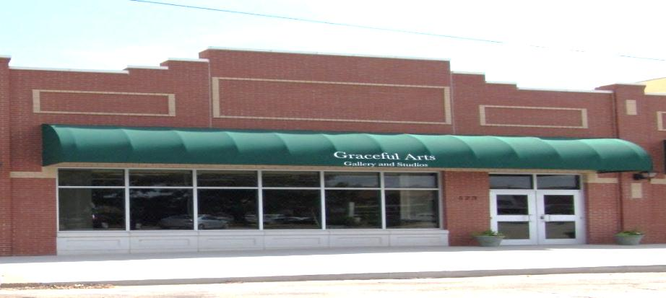
Graceful Arts Center

Fall Class Schedule 2022
Classes/Time Start Date Tuition
After-School Art Classes
Tuesday Beginners Draw to Paint (8-14yr - 3:30-5:30) September 6th, October $40 monthly
*Some supplies required* November, December

Every Wednesday After-School Art Basics (K-12yr - 3:30-5:00) Starts-August 17th $10/weekly
With Emma Cline – Drop-in’s Welcome September
October
November
Ends-December 14th
Thursday Jr. Duck Stamp National Contest (3:30-5:30) September 1st-November 17th $75

Friday Make-n-Take (ages K-12yr) 3:30-5:30
Patriotic Craft (3:30-5:30pm) August 26th $15
Paint a Pumpkin (3:30-5:30pm) September 23rd $15
Festive Fall Craft (3:30-5:30pm) October 21st $15
Holiday Fun Craft (3:30-5:30pm) November 18th $15
Christmas Craft (3:30-5:30pm) December 9th $15

SaturdayWorkshops - ALL AGES – Pre-Enrollment REQUIRED
Acrylic Painting with Michael Elizondo 10a-3p October 1st $60
Watercolor Workshop with Jerry Piper 10a-3p October 8th $65
Beginning Crochet with Jenny Sattler 10a-12noon November 12th $20
Intermediate Crochet with Mary Reigel 1p-3p November 12th $20
Mixed Media with Deborah Burian 10a-3pm November 19th $65
Paint Your Art Out with Emma Cline Aug 12, Sept 9, Oct 14, Nov 18, Dec 16 $30
Artists Talks First Friday Art Walk (6-8pm) Aug 5th, Sept 2nd, Oct 7th, Nov 4th, Dec 2nd Free to Public

We Do Paint Parties! Call to Schedule Your Event with Us!
580-327-ARTS (2787)
523 Barnes Alva, Ok 73717
gracefulartscenter@gmail.com
*Like us on Facebook*
**No Classes 10/13, 11\21-24, 12/19-1/4**

